Your first read on sailing should be a text book on the fundamentals, that has quality content that you can reference as you learn. If you already have some experience sailing then a reference such as the “Sailing Bible” may be more appropriate. There thousands of print and digital works available to choose from. With that said, the Mountaineers “Basic Keel Boat” program is just that. Basic. Save the specialized sailing topics for after you have mastered the fundamentals. Below are just a few sail training reads that fits what you will be learning in the Mountaineers Sailing program.

Sailing Made Easy (ASA Textbook 101) $29.95 on Amazon
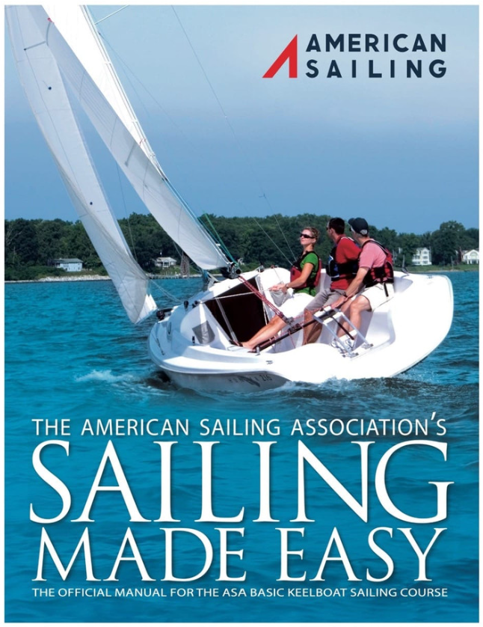
Sailing Made Easy is the first step in a voyage that will last you the rest of your life. It is a gift from a group of dedicated sailing professionals who have committed their lives to sharing their art, their skill, and their passion for this wonderful activity.
This book, which Sailing Magazine called "best in class" upon its release, is the most comprehensive education and boating safety learn-to-sail guide to date. It is also the official textbook for the ASA Basic Keelboat Standard (ASA 101). Incorporated in the textbook are useful illustrations and exceptional photographs of complex sailing concepts. The text’s most distinguishing feature is its user friendly "spreads" in which instructional topics are self-contained on opposing pages throughout the book. There are also chapter end quizzes and a glossary to help those new to sailing to navigate their way through the extensive nautical terminology.

Basic Keelboat Book (US Sailing) $25.95, available in digital format as well as print
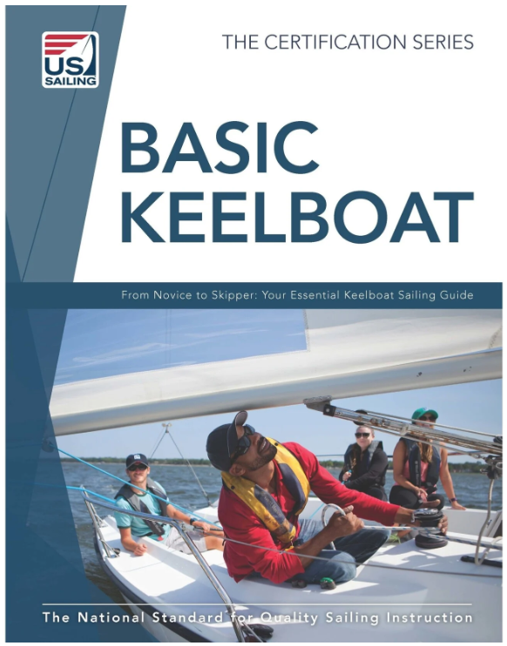
(No narrative)
Sailing: The Basics: The Book That Has Launched Thousands $14.83 on Amazon (4.5 rating)
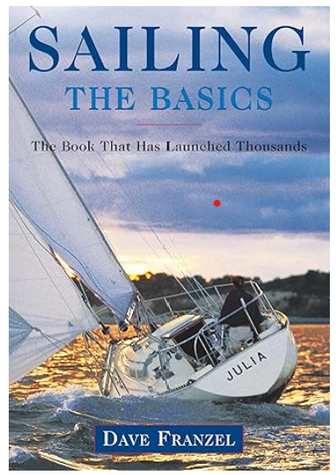
Quickly and easily master the sailing fundamentals you'll need to get out on the water.
The Sailing Bible: The Complete Guide for All Sailors from Novice to Expert $32.95 on Amazon
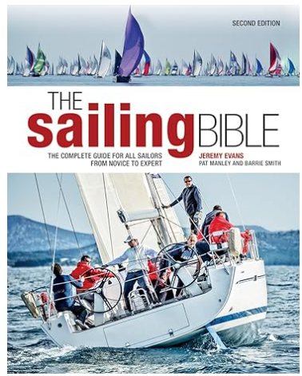
"Sailing is a popular sport and this book is a very comprehensive treatment of the subject.... The volume is well illustrated with color photographs [and] this reviewer was impressed by the constant stress the authors place on safety at sea.... This title is recommended for general reference collections."
--American Reference Books Annual

